Session 3
task 1 : Create a SQL table called Restaurants with columns: id (INT, auto-increment), name (VARCHAR), cuisine (VARCHAR), rating (DECIMAL), and city (VARCHAR). Insert 5 sample restaurants into the table, each with a different cuisine and rating.
Query

SELECT * FROM Restaurants;
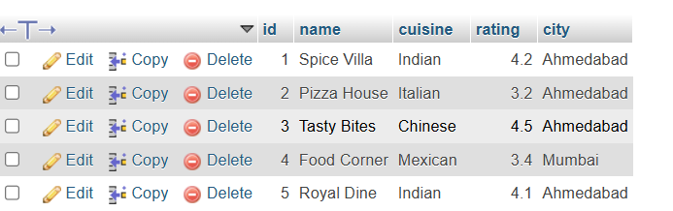
Task 2:
Write a SQL UPDATE statement to change the rating of the restaurant named 'Spice Villa' to 4.7 in the Restaurants table.
Query

UPDATE Restaurants
SET rating = 4.7
WHERE name = 'Spice Villa';
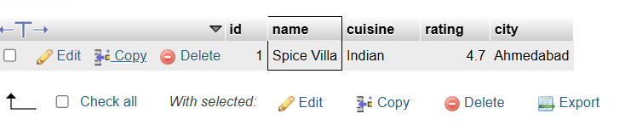
Task 3:
Delete all restaurants from the Restaurants table where the rating is less than 3.5 using a SQL DELETE statement.
Query

DELETE FROM Restaurants
WHERE rating < 3.5;
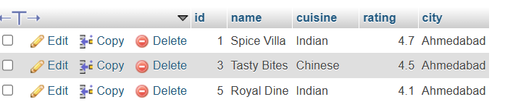
Task 4:
Use a SELECT query with WHERE and LIMIT to fetch the top 2 restaurants in the city 'Ahmedabad' with a rating above 4.0 from the Restaurants table.<br><br><em><strong>Hint:</strong> Combine WHERE for city and rating, and LIMIT to restrict the number of results.</em>
Query

SELECT *
FROM Restaurants
WHERE city = 'Ahmedabad'
LIMIT 2; AND rating > 4.0


